Network Design – Custom Tunneling Lab
Hayden Weber

Initial Setup
This challenge was built and tested entirely within VMware Workstation Pro. Workstation Pro is a hosted/type 2 hypervisor capable of running virtual machines within an existing operating system. A total of 7 individual virtual machines were configured within the software to create this environment. This includes:
- 1 Kali Linux Box
- 1 Ubuntu Desktop Box
- 5 Ubuntu Server Boxes
A default installation of Kali, including their recommended tools, has everything required to complete this challenge. All the Ubuntu machines are default installations configured to have the various required services for this challenge, which is well-documented further on.

Network Configuration
Each target machine in this lab is configured with two network interfaces. It’s configured this way so each machine is connected to only two subnets, meaning each system has a direct line to just a single machine in either direction. They’re unable to see any of the other machines on this network because they sit in different subnets. This configuration is better visualized by the following IP table, as well as the provided network diagram. For the simplest explanation, please view the provided file “Network Diagram.html”.
Hostname | Eth0 IP | Eth1 IP | VMnet | Operating System
testbox | N/A | 192.168.222.130 | VMnet9 | Kali
gateway | 192.168.222.128 | 192.168.157.128 | VMnet9,  VMnet10, | Ubuntu Desktop
second-hop | 192.168.157.129 | 192.168.118.128 | VMnet10,  VMnet11 | Ubuntu Server
third-hop | 192.168.118.129 | 192.168.54.129 | VMnet11,  VMnet12 | Ubuntu Server
fourth-hop | 192.168.54.128 | 192.168.4.128 | VMnet12,  VMnet13 | Ubuntu Server
fifth-hop | 192.168.4.129 | 192.168.244.128 | VMnet13,  VMnet14 | Ubuntu Server
final-destination | 192.168.244.130 | N/A | VMnet14 | Ubuntu Server
** IP Addresses marked with “N/A” are not necessary for completing the lab

Services
Every target system in this lab is configured to be an SSH client and server. This is a strict requirement, as SSH tunneling is how the exploitation of the final target system is accomplished. There are also two websites and a Trivial File Transfer Protocol (TFTP) server, as outlined below. These services are included either as puzzles to gain valuable information for the challenge, or rabbit holes that provide a hint at the end.
Ubuntu Desktop: gateway
- SSH (Port 22)
- Apache Web Server (Port 80)
  - Hosts a website that requires deep investigation to discover the hidden SSH credentials.
- TFTP Server (Port 69)
  - Hosts a file named “secret” which, upon opening, provides a hint pointing towards the web server.
Ubuntu Server: second-hop
- SSH (Port 22)
Ubuntu Server: third-hop
- SSH (Port 22)
Ubuntu Server: fourth-hop
- SSH (Port 22)
Ubuntu Server: fifth-hop
- SSH (Port 22)
Ubuntu Server: final-destination
- SSH (Port 22)
- Apache Web Server (Port 80)
  - Hosts a website with three puzzles to solve, which awards the final flag for the challenge.

VMnet Configuration
This section outlines the virtual network configuration for this lab within VMware Workstation Pro. These settings can be changed within the Workstation software at Edit -> Virtual Network Editor. The exact settings used in this lab can also be imported directly into an existing Workstation setup by selecting import within the Virtual Network Editor and choosing the provided “VM Config” file. If manually configuring, make sure to uncheck “Connect a host virtual adapter to this network”. Otherwise, VMware will create a virtual network adapter on the host computer for every single network created.

Virtual Network | Subnet IP | Subnet Mask
VMnet9 | 192.168.222.0 | 255.255.255.0 (/24)
VMnet10 | 192.168.157.0 | 255.255.255.0 (/24)
VMnet11 | 192.168.118.0 | 255.255.255.0 (/24)
VMnet12 | 192.168.54.0 | 255.255.255.0 (/24)
VMnet13 | 192.168.4.0 | 255.255.255.0 (/24)
VMnet14 | 192.168.244.0 | 255.255.255.0 (/24)

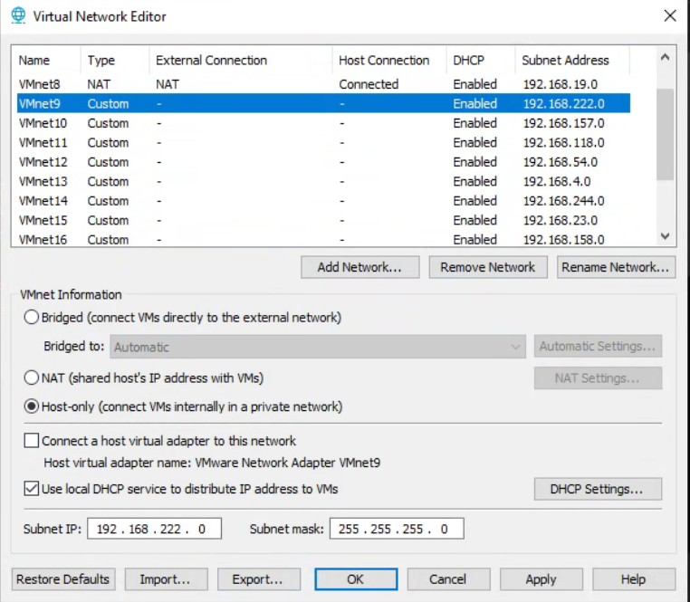

Virtual Machine Configuration
Kali Machine – testbox
The hardware allocation detailed in the below screenshots are not strict requirements. However, it is important to allocate enough system resources so Kali can run smoothly while completing this challenge. The target systems in this lab do not acquire nearly the same amount of resources as Kali, so most of what can be spared on the host system should be put into this machine. The one crucial piece of this setup that must be replicated is the network adapter on VMnet9. This is the first connection in the network that was previously configured. (Having an interface for NAT will provide the Kali machine with access to the internet, but it is not required to complete the lab.)
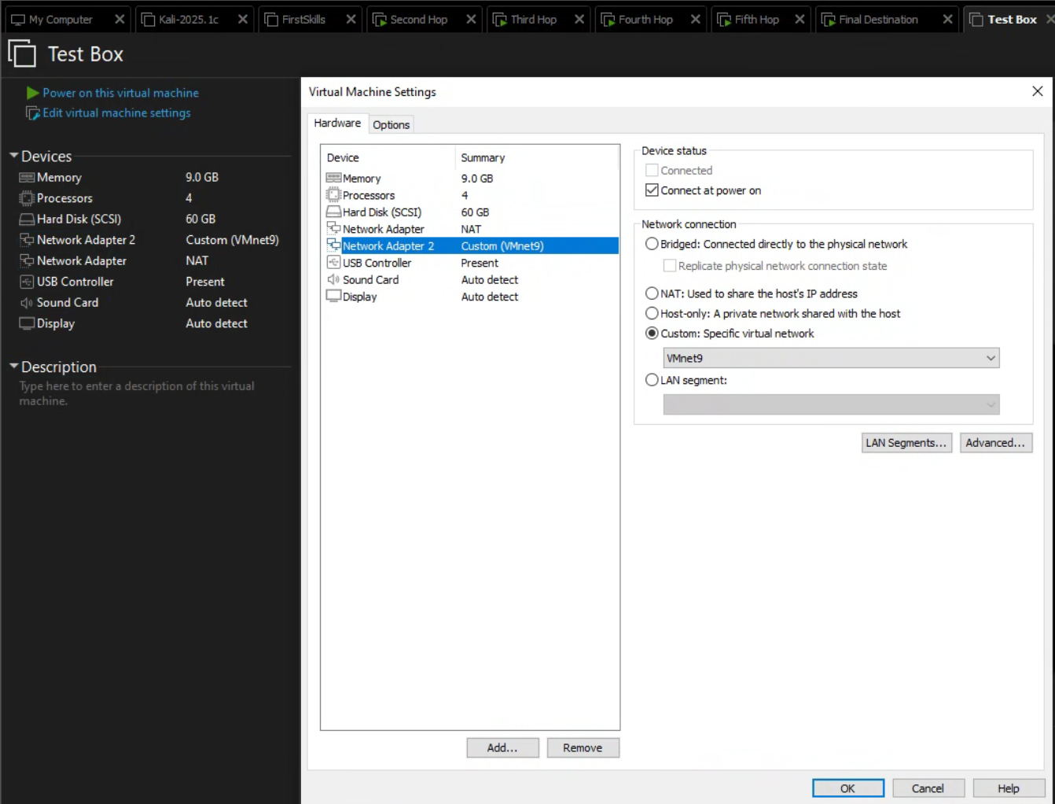

Ubuntu Desktop – gateway
VMnet9 and VMnet10 are the network interfaces for the gateway machine. VMnet9 connects back to the original Kali box, and VMnet10 connects to the next target machine.
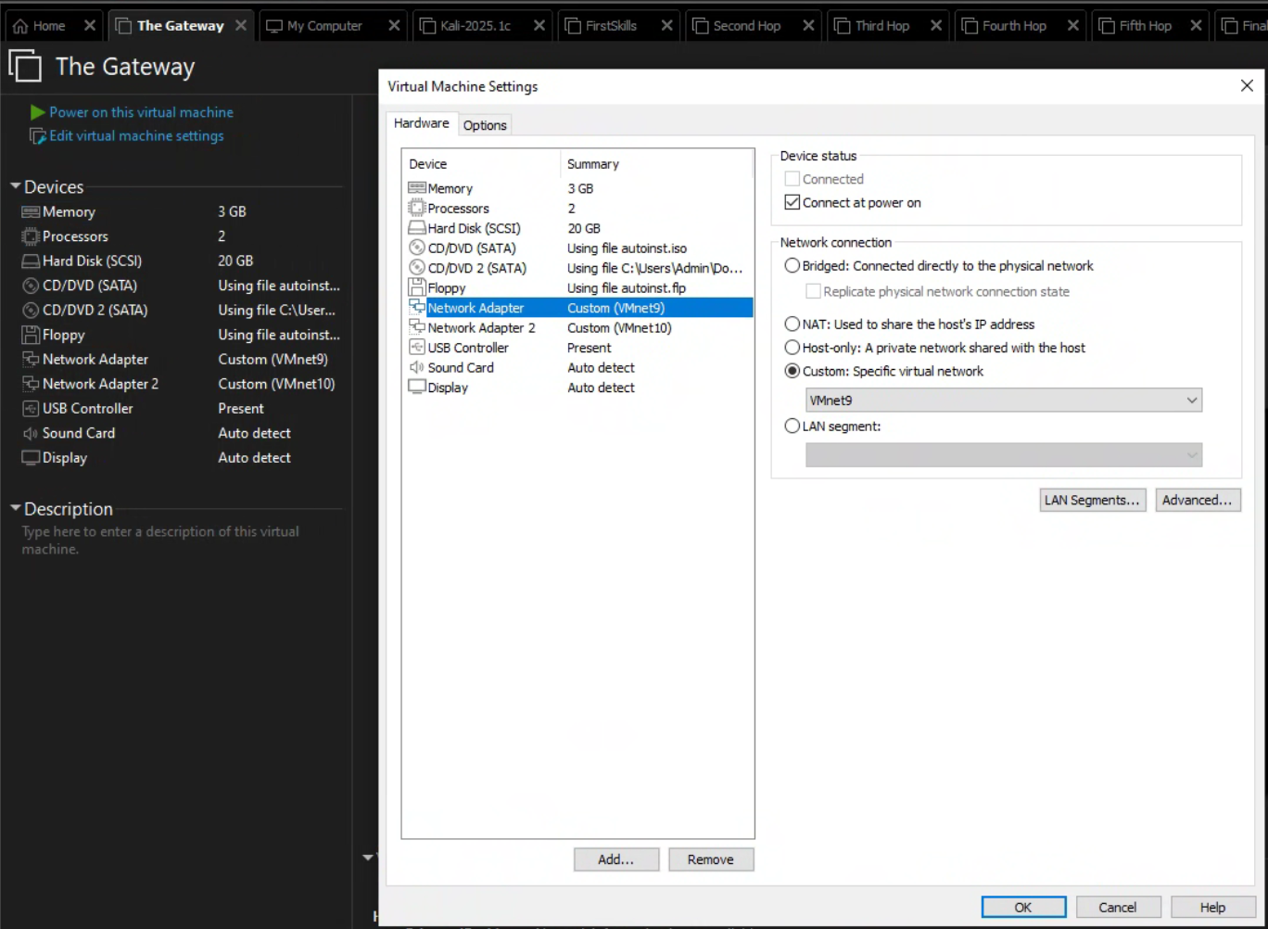

Ubuntu Server – second-hop
VMnet10 and VMnet11 are the network interfaces for the second-hop machine. VMnet10 connects back to the previous gateway machine, and VMnet11 connects to the next target machine.
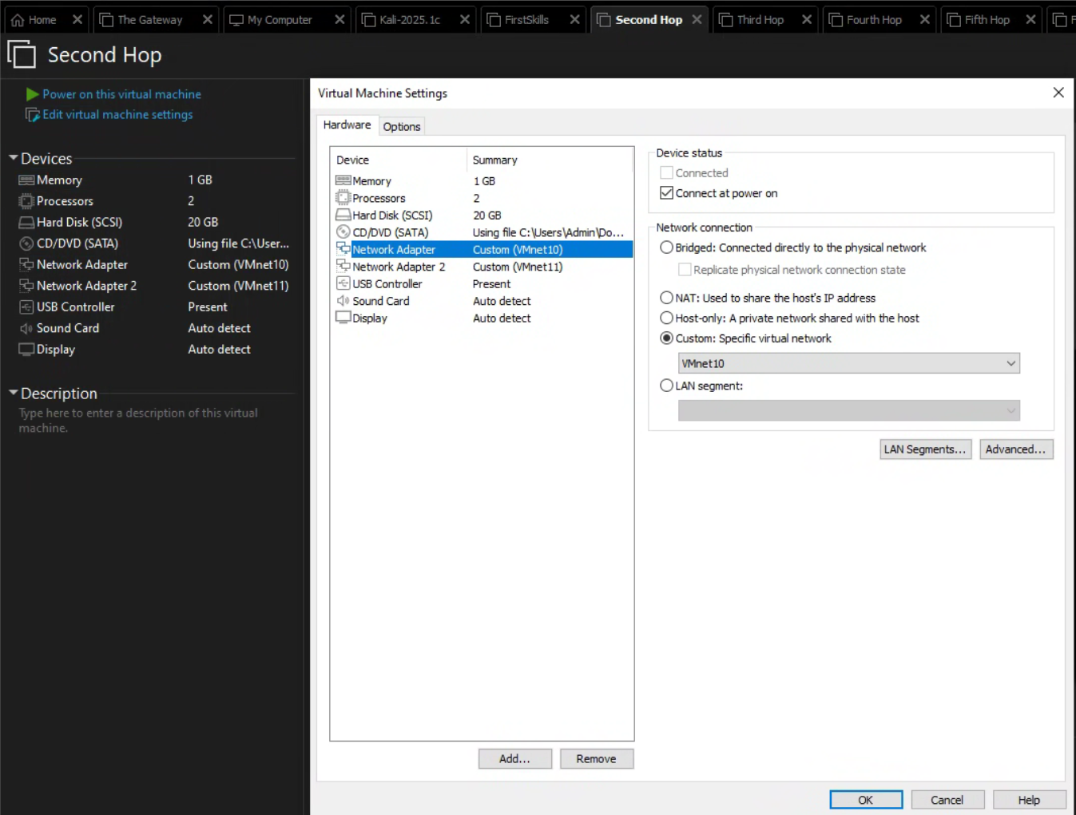

Ubuntu Server – third-hop
VMnet11 and VMnet12 are the network interfaces for the third-hop machine. VMnet11 connects back to the previous second-hop machine, and VMnet12 connects to the next target machine.
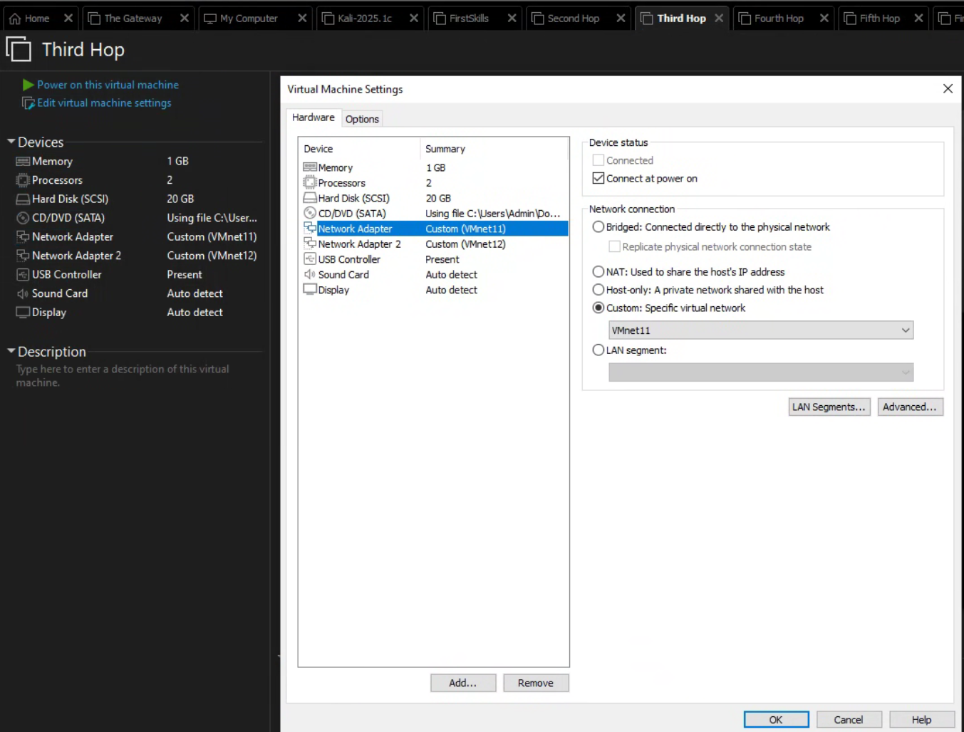

Ubuntu Server – fourth-hop
VMnet12 and VMnet13 are the network interfaces for the fourth-hop machine. VMnet12 connects back to the previous third-hop machine, and VMnet13 connects to the next target machine.
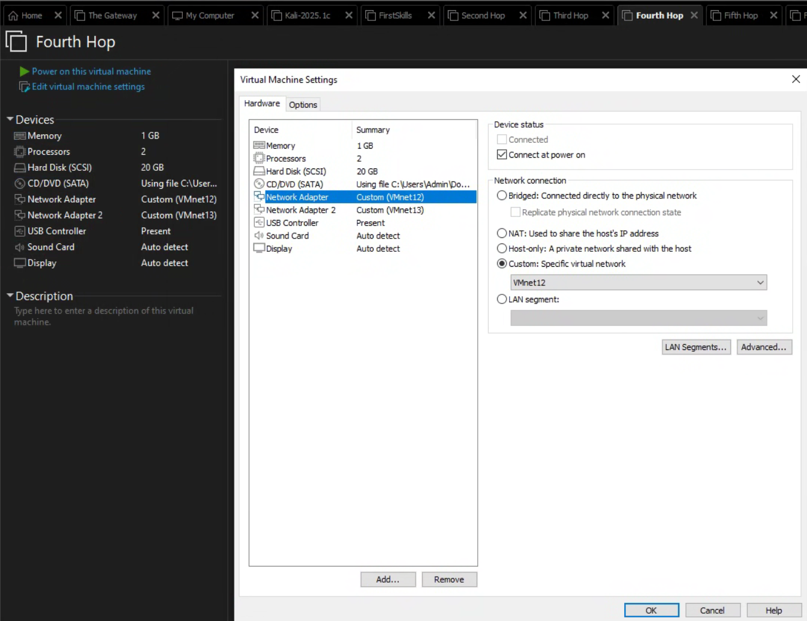

Ubuntu Server – fifth-hop
VMnet13 and VMnet14 are the network interfaces for the fifth-hop machine. VMnet13 connects back to the previous fourth-hop machine, and VMnet14 connects to the next target machine.
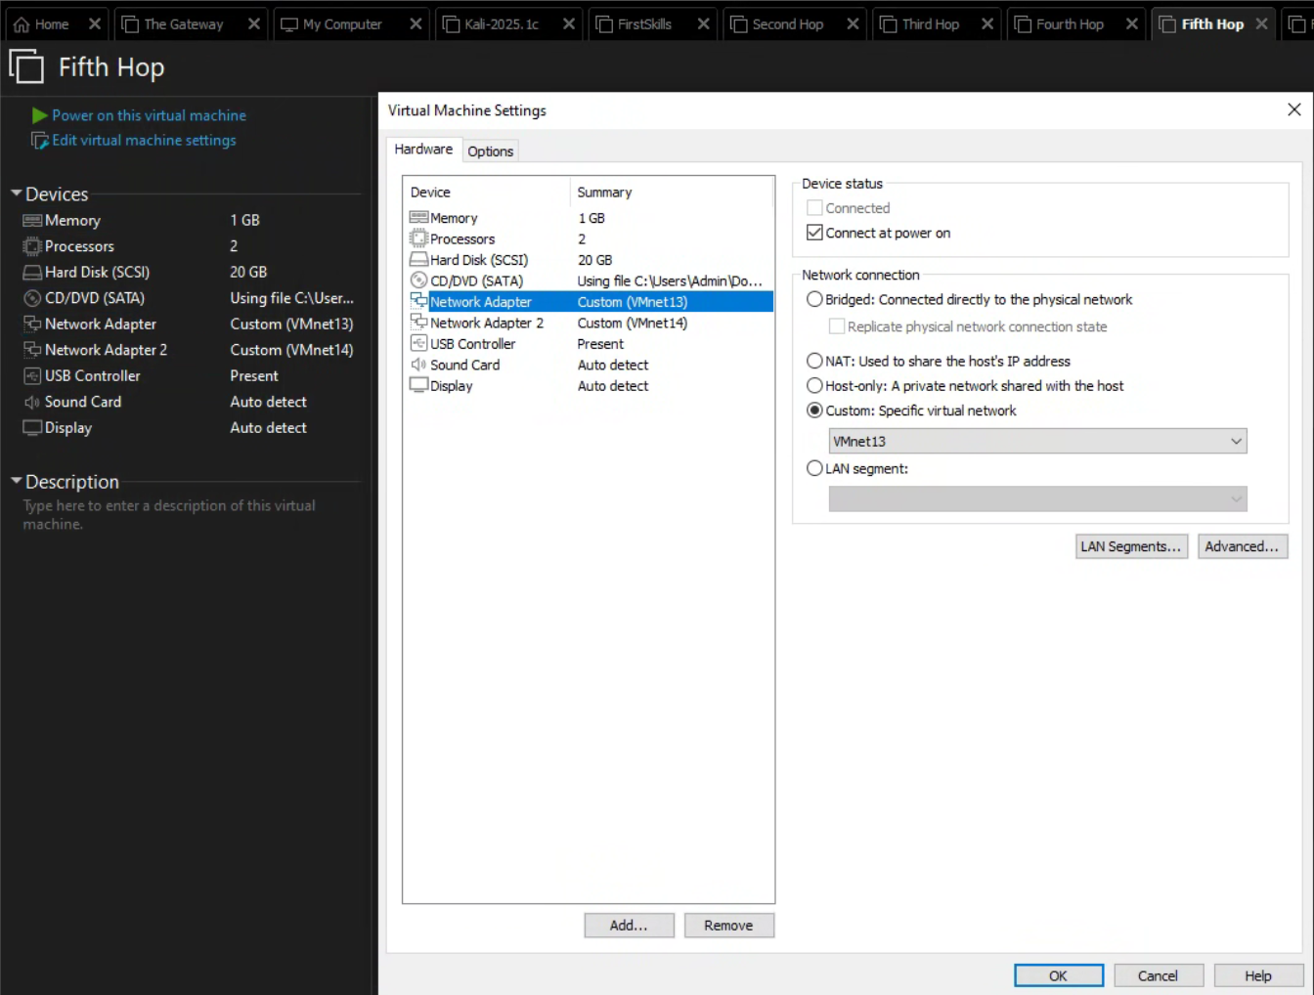

Ubuntu Server – final-destination
VMnet14 is the network interface for the final-destination machine. This connects back to the previous fifth-hop machine.
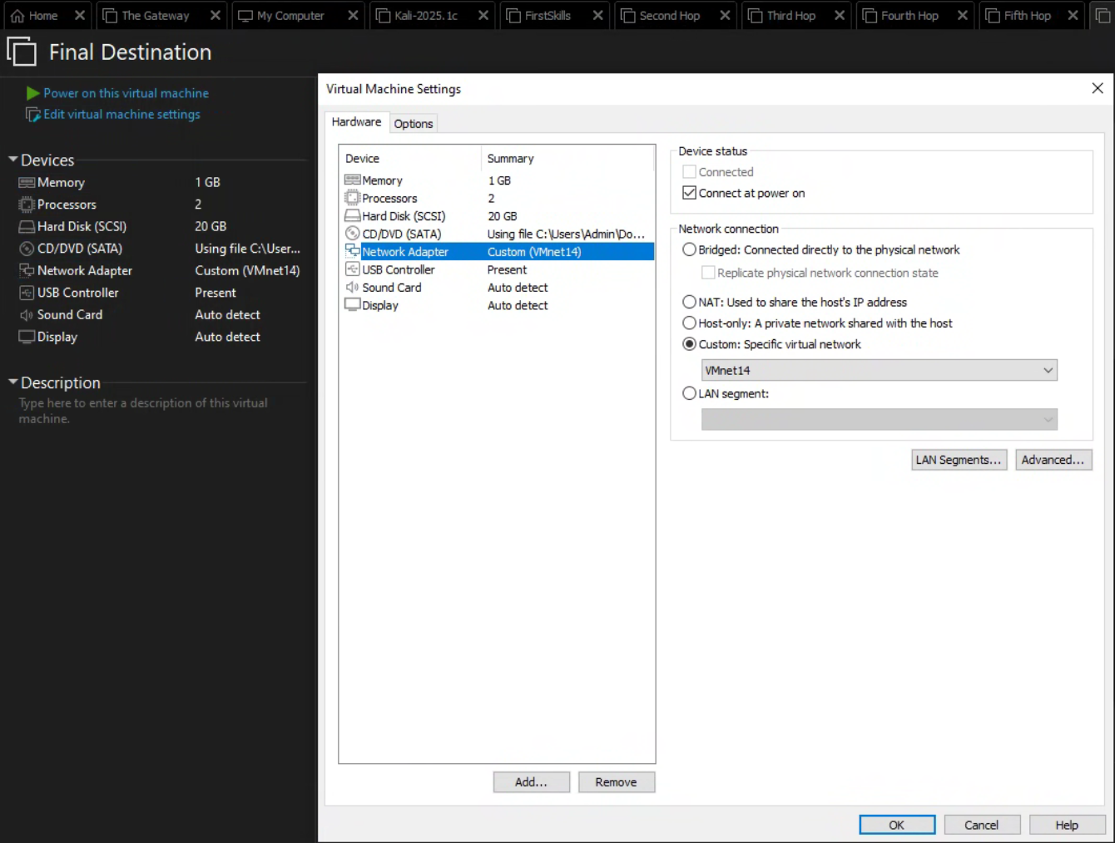

Glossary
Virtual Machine – A VM is a computer resource that functions like a physical computer, making use of software resources instead of physical computer hardware. The experience for the end-user is effectively identical to that of a regular computer.
Type 2 Hypervisor – A type 2 hypervisor is a program/software installed on a host operating system. It’s responsible for creating and managing virtual machines.
Subnet – A subnet is a logical division of an IP network.
Kali Linux – A popular Debian-based Linux distribution designed for penetration testing.
Ubuntu Desktop – A mainstream Linux distribution designed for regular use.
Ubuntu Server – A command line only Linux distribution designed for server use.
Service – A term used to refer to any application running on a computer that can be accessed on a network through a port.
Network Interface – Often abbreviated as NIC, for Network Interface Card, a network interface refers to the hardware component that connects a device to a network. In the context of virtual machines, the network interface is also virtual. On normal devices, it is a physical hardware component.

